**VENDING MACHINE TECHNICAL DOCUMENTATION**

***Team H***

***15.06.23***

1. **Team members**

Maxim Emile Speczyk

Muhammad Umer Bin Yaqoob

Stephanie Chinenye Okosa

1. **Concept description**

In this project, we aim to design a hardware system for a vending machine using Field-Programmable Gate Arrays (FPGA), as well as designing our own PCB to its specific needs.

Ein Bild, das Text, Diagramm, Screenshot, Schrift enthält.
The vending machine’s main applications are to dispense an item, accept coins, as well as calculate and dispense the change. For this we use switches to select the item and coin input. Also, the 7-segment display shows the cost of an item, refund price and the insufficient amount.

Figure 1 is the state machine of the vending machine. In the state “Idle”, the system waits for input of the item that is requested. After the item is requested, the money needs to be accepted, which happens in the state “Accepting”. After enough money is detected, the item gets dispensed and the state changes to “Dispensing”. Then the system changes to the state “Refund” which includes calculating and giving out the change back to the customer.

Figure 1: Vending Machine FSM

Below is the block diagram which illustrates the components of the vending machine.

**Ein Bild, das Text, Screenshot, Schrift, Zahl enthält.
**

Figure 2: Vending Machine Block Diagram

**3 Project Team management**

We used Scrum which is a subset of agile methodology. Every week we would discuss the project’s progress and come up with to-do tasks. In the beginning, the team had a planned meetings to decide what to work on during the upcoming week and the idea was discussed. We followed a collective way of solving different tasks in which each of us would work together at every step of the project.

*The following were the tasks worked upon:*

**Brainstorming and concept creation:** All team members worked together to brainstorm and formulate the initial idea for the smart greenhouse. Each team member contributed their unique perspectives and ideas to create a viable project plan.

**Block Diagram and Circuit Design**: All three members contributed to the design and development of the block diagram. Also, the schematic, PCB design and 3D view layout of the circuit on KiCAD was accomplished as a collective effort. Each member brought their own ideas, and through discussion and iteration, they came up with the final diagrams.

**Coding and Implementation**: The coding and implementation of the vending machine concept and circuit design was a shared task. Each team member wrote sections of the code using different ideas to troubleshoot our issues. We worked together to ensure a compilation and simulation of the code in model SIM and proper synthesis and implementation of our code on the FPGA board.

**4 Implementation**

**KiCAD**: This tool is used to create the schematic for the vending machine circuit based on the functionalities as defined in the concept section. Here an evaluation board is given that contains libraries of the footprint and schematic for designing hardware with an FPGA board. This serves as the basis for designing the power supply, utilities and vending machine hardware circuit schematics as shown in figures 3, 4 and 5 respectively. In Figure 5, we make use of the switches and 7 segment display of the FPGA thus the reason for adding the symbols to the schematic. In order to generate the PCB layout, we must assign components to the symbols, by creating the footprint of the schematic and assigning components from the footprint libraries provided.

Figure 3: Circuit Power Supply Schematic

Figure 4: Circuit Utilities Schematic

Figure 5: Circuit Vending Machine Schematic

These changes made in the schematic by assigning components are updated to the PCB and then an outline is placed around as seen in figure 6, which corresponds to the size of the board. Auto-routing is performed to route the tracks on the board using an online free routing tool. A 3D view of the board can also be seen and saved as a .png file as shown in figure 7.

Figure 6: PCB Vending Machine without Auto Routing

Figure 7: 3D view Vending Machine PCB

**MODELSIM**: Here the code for implementing the vending state machine is written. Three items are assumed to be contained in the vending machine. The users are expected to select an item and select the amount being placed into the machine. These items are being stored as products to identify the items being selected, and specific prices are assigned to each item. Signals are being used to determine the state of the machine from the idle state till an item has been dispensed from the machine. The DecoderBIt component enables the output values to be displayed on the 7-segment display as illustrated in Figures8, 9, and 10 respectively.

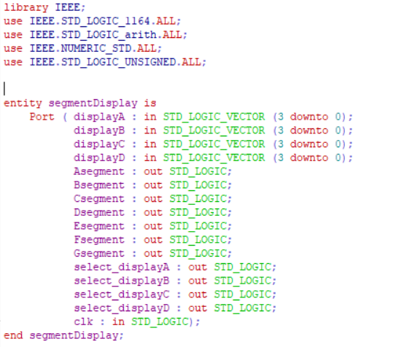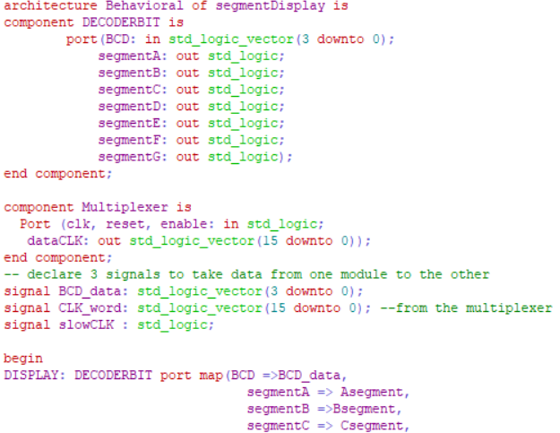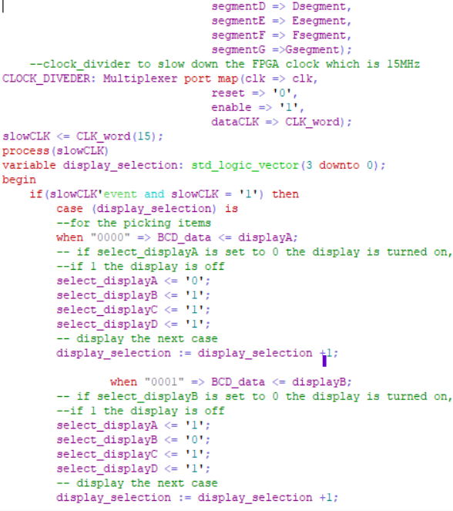

Figure 8: Decoder Bit Code

Figure 9:Multiplexer VHDL Code

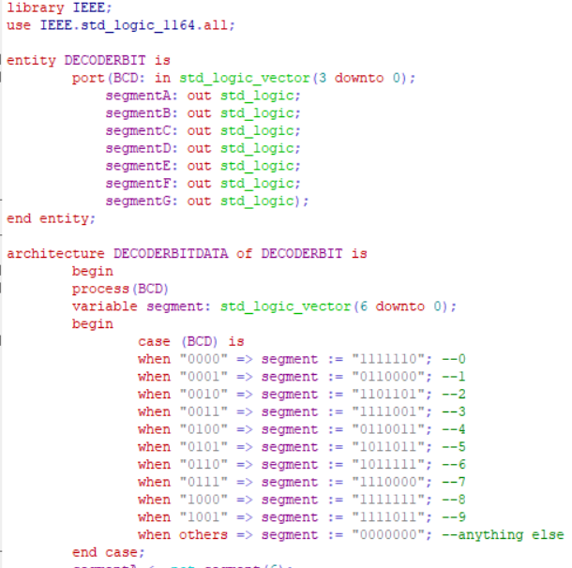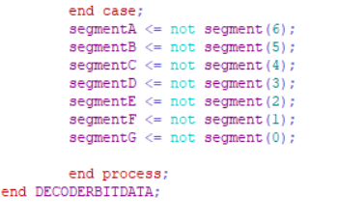

Figure 10:7 Segment Display VHDL Code

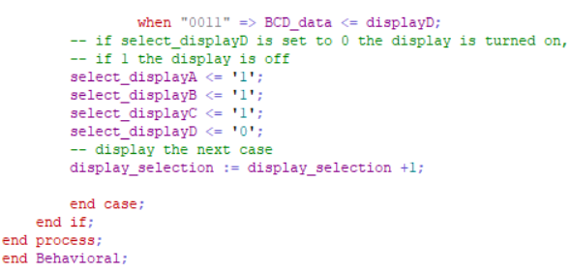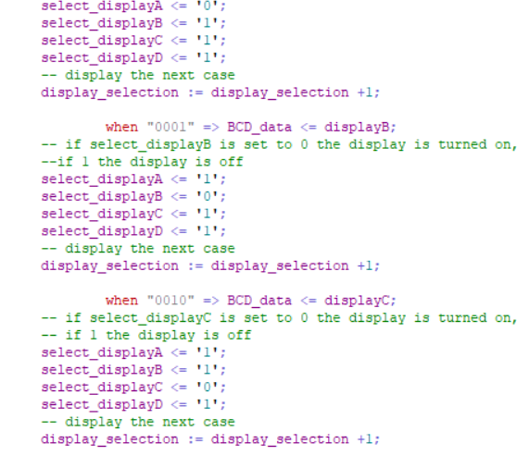

Figure 11: Vending Maching FSM implementation-2

Figure 12: Vending Maching FSM implementation-1

Figure 13: Activated Ports in constraint file VIVADO

**VIVADO:** This is an environment used for synthesizing, implementing, routing design and, generating bit stream of the VHDL code that would be uploaded to the FPGA board to perform the designed logic.

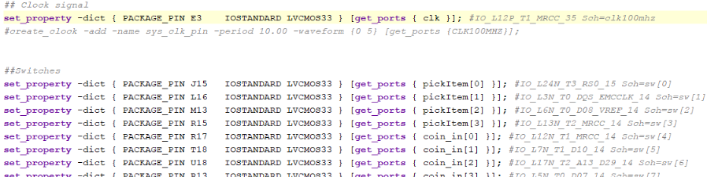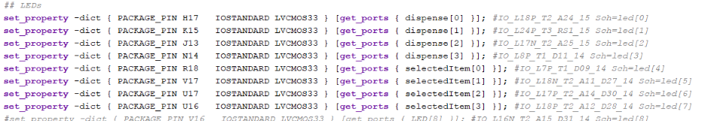

Figure 14: Figure 11: Vending Maching FSM implementation-3

When a user inputs the value for money being used in purchasing an item. When the value amount is more than the price of the item, the machine displays the refund value, else it waits for the user to put in the remainder amount. The display then shows the item being dispensed.

